Controller Box SBC Updates
The controller box requires a jumper (see picture) to support +5v only power supply and automatic power on condition.
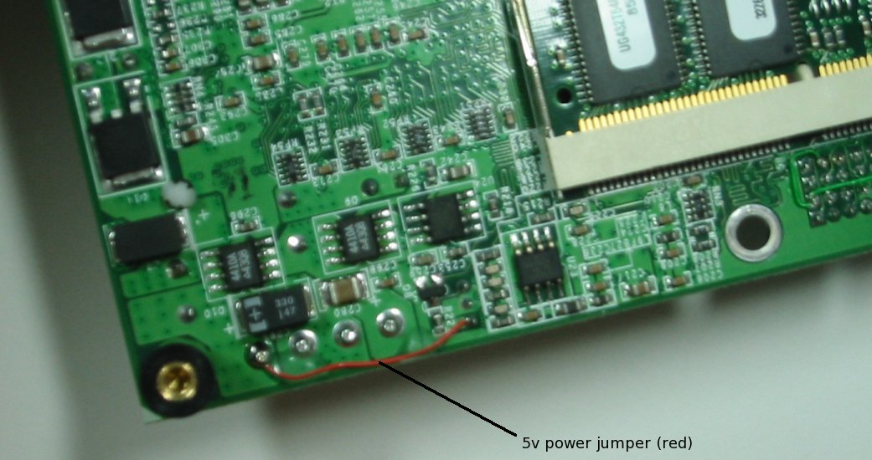

The BIOS settings should be set to reflect the following:

[Date & Time]
Date DD MMM YYYY
Time HH:MM:SS
[Drive Assignment]
Drive A (none)
Drive B (none)
Drive C (none)
Drive D (none)
Drive E (none)
Drive F (none)
Drive G (none)
[Boot Order]
Boot 1st (none)
Boot 2nd (none)
Boot 3rd (none)
Boot 4th (none)
Boot 5th (none)
Boot 6th (none)
[Drive and Boot Options]
Floppy over Parallel Disabled
Floppy Seek Disabled
Hard disk Seek Disabled
Floppy Swap Disabled
Boot Method Boot Sector
Primary IDE Cable Auto
Secondary IDE Cable Auto
Secondary Master ATA mode LBA
Secondary Slave ATA mode LBA
[Keyboard and Mouse]
Numlock Disabled
Typematic Enabled
Delay 250 ms
Rate 30 cps
Initialize PS/2 Mouse Enabled
[User Interface]
Show 'Hit <Del>...' Enabled
F1 Error Wait Disabled
Config Box Enabled
Splash Screen Disabled
[Memory]
Memory Test Fast
Memory Hole Disabled
Shadow D000-D3FF Disabled
Shadow D400-D7FF Disabled
Shadow D800-DDBFF Disabled
Shadow DC00-DFFF Disabled
[DRAM]
DRAM Clock Frequency SPD
DRAM CAS Latency SPD
[Power Managment]
ACPI Enabled
APM Disabled
[Advanced features]
Post Memory Manager Disabled
CPU Serial Number Enabled
Watchdog Timeout (sec) Disabled
Serial Console Hot Cable
Port 3F8h
USB Boot Support Disabled
Lan Boot Lan 1
[On-Board Serial Ports]
Serial 1 3F8h
IRQ 4
Serial 2 2F8h
IRQ 3
Serial 3 Disabled
IRQ 11
Mode RS-232
Serial 4 Disabled
IRQ 10
Mode RS-232
[On-Board LPT Port]
LPT 1 378h
IRQ 7
DMA 3
Mode Standard
[On-Board Controllers]
Floppy Disabled
Primary IDE Enabled
Secondary IDE Enabled
PS/2 Mouse Enabled
USB 2 Ports
Audio Disabled
[On-Board Video]
Framebuffer Size 8MB
AGP Aperture Size 32MB
Display CRT
Panel Type 640x 480x18 TFT
[On-Board Audio Legacy]
SoundBlaster Disabled
IRQ 5
DMA 1
MPU 401 Midi Disabled
[PCI]
INTA IRQ 5
INTB IRQ 9
INTC IRQ 5
INTD IRQ 9
[Plug and Play]
PnP BIOS Enabled
PnP OS Enabled
Assign IRQ 1 Disabled
Assign IRQ 3 Enabled
Assign IRQ 4 Enabled
Assign IRQ 5 Enabled
Assign IRQ 6 Disabled
Assign IRQ 7 Enabled
Assign IRQ 9 Enabled
Assign IRQ 10 Enabled
Assign IRQ 11 Enabled
Assign IRQ 12 Disabled
Assign IRQ 14 Disabled
Assign IRQ 15 Disabled
Assign DMA 0 Disabled
Assign DMA 1 Disabled
Assign DMA 2 Disabled
Assign DMA 3 Enabled
Assign DMA 5 Enabled
Assign DMA 6 Enabled
Assign DMA 7 Enabled

